**Title: Application of EM algorithm, EM algorithm for mixture method.**

Q1) Consider the sample x=(0.12,0.17,0.32,0.56,0.98,1.03,1.10,1.18,1.23,1.67,1.68,2.33)

Generated from an exponential mixture

pexp(λ)+(1-p)exp(μ) all parameters p, λ, μ are unknown.

The likelihood h(p, λ, μ) can be expressed as E[H(x,Z)] where z=(z1,z2,…….,z12) corresponds to the vector of allocations of the observations xi to the first and second components of the mixture;

P(Zi = 1) = 1 − P(Zi = 2) = pλ exp(−λxi) / [pλ exp(−λxi) + (1 − p)µ exp(−µxi)]

Construct EM algorithm for this model derive maximum likelihhod estimators of the parameters for sample provided above.

ANS:

Code:

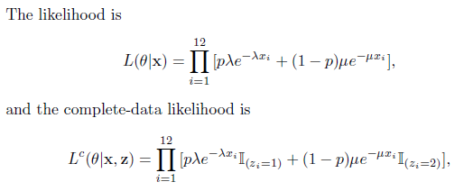

The EM algorithm relies on the optimization of the expected log-likelihood

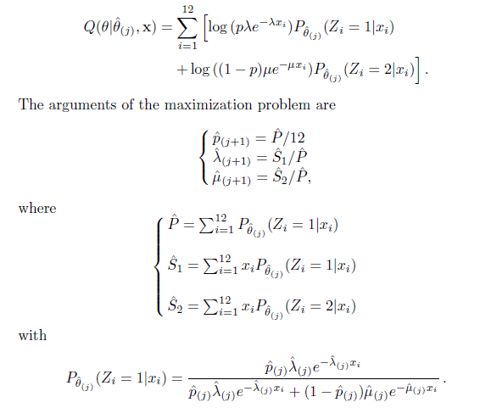

x=c(0.12,0.17,0.32,0.56,0.98,1.03,1.10,1.18,1.23,1.67,1.68,2.33)

EM=cur=c(.5, jitter(mean(x),10),jitter(mean(x),10))

diff=1

while (diff*10^5>1){

probs=1/(1+(1-cur[1])*dexp(x,cur[3])/(cur[1]*dexp(x,cur[2])))

phat=sum(probs);S1=sum(x*probs);S2=sum(x*(1-probs))

EM=rbind(EM,c(phat/12,S1/phat,S2/phat))

diff=sum(abs(cur-EM[dim(EM)[1],]))

cur=EM[dim(EM)[1],]

}

> cur

**[1] 0.5000422 1.0308074 1.0306854**

Q2)

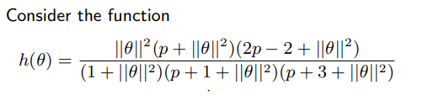

when θ ∈ Rp and p = 10. For above situation following data (x1, x2, x3, x4) = (125, 18, 20, 34) are collected. Construct an EM algorithm to find the MLE of θ.

Ans:



x=c(58,12,9,13)

n=sum(x)

start=EM=cur=diff=.1

while (diff>.001){ #stopping rule EM=c(EM,((cur*x[1]/(2+cur))+x[4])/((cur*x[1]/(2+cur))+x[2]+x[3]+x[4])) diff=abs(cur-EM[length(EM)])

cur=EM[length(EM)]

}

> cur

**[1] 0.1**